

**Midterm Assignment**

JongCheol Air

Business Software Systems – SYST16529, Lecture 2930

Instructor: Susan Burgess

Amir Moazzami, Meghan Cunningham, Abraham Salem, Musawar Taseer

**Mission Statement**

At JongCheol Air, we firmly believe in the three standards of flight as stated by our company’s founder: JongCheol Park. We believe in safety, comfort and reliability. At JongCheol Air, it is our duty to ensure our customers are given the best service available when it comes to inflight entertainment and comfort. We seek to continuously innovate and improve our methods of inflight hospitality and keep a high luxury standard of accommodation and high class flight service. When our customers ride with JongCheol Air, they’re riding with class, status and high credibility.

**Company Profile**

History

JongCheol Air is a subsidiary of JongCheol Incorporated. JongCheol Inc. started back in 1898 in Hanseong, Korean Empire. The company began with a young man named Jong Sung Park who would sell figurines on the streets of Hanseong (Modern day: Seoul) during the aftermath of the Donghak Peasant Revolution of 1984. Although Jong Sung Park’s figurines were popular amongst children in Hanseong, the company became a major success only after the annexation of Korea by the Japanese Empire in 1910. JongCheol Air was formed in 1993 by Jong Sung Park’s great grandson: JongCheol Park, who is the current President and CEO of JongCheol Inc. JongCheol Air is one of 4 different subsidiaries of JongCheol Inc. The other 3 are: JongCheol Electronics, JongCheol Motors and the ever popular JongCheol Bath & Body. JongCheol Air is a luxury airline which provides private luxury flights for high status celebrities and politicians. At JongCheol Air, we have over 2000 staff members including engineers, flight attendants, and our hard-working employees at our head offices in Seoul, South Korea and Toronto, ON.

**Company Overview**

Synopsis

JongCheol Air is committed in providing a workplace environment that treats all employees with respect and dignity. When opportunities for employment or promotion occur, hiring managers seek best qualified candidates and hire accordingly. Short-term and long-term contracts are available throughout all company levels. They will vary from job to job, according to the requirements and conditions of the work.

With respect to being an Airline, JongCheol Air does not only hire pilots. While pilots jobs are very important, they only make up a small portion of the team that gets you to your desired destination. JongCheol Air hires a wide variety of talent, to ensure our company's success. These jobs include Flight Attendants, Airline Administrative Support, Operations Agents, Avionics Technicians, Mechanics, Regional Sales Managers, Schedule Coordinators, Station Agents and Ticket Agents. We provide efficient service to our customers, and establish a climate which employees can maximize their contribution for the achievement of corporate objectives, and professional growth. To improve representation of designated groups, JongCheol Air will take corrective measures as necessary. The company requires all employees to conform to appropriate behaviour standards and a suitable level of work performance. Based on work initiation and evaluation activities, employees are subject to disciplinary action, as well as provision of rewards and recognition.

**Departments and Employees**

Regional Sales Manager

Managers are accountable for the timely development and communication of objectives, standards, and expectations. Annual and long-term goals will be set for employees based on, corporate strategy, performance capabilities and experience. If an employee fails to achieve established work objectives, or meet established standards, the manager will immediately initiate a review with the employee, to clarify the potential causes and options for correction. Our managers are forecasted to make between $58k-$64k CAD yearly.

Mechanic

JongCheol Air is responsible for your safety and well being during your flight. To ensure that the aircraft if flight ready, we hire a team of mechanics to do routine testing of the system. JongCheol Air is committed to, and promotes the highest standards of aircraft safety. Our mechanics will check all hardware, and software on aircraft before takeoff to establish a problem-free environment for our customers. Our Mechanics are forecasted to make around 68k CAD yearly.

Flight Attendant (Hourly)

At a minimum, Flight Attendants must comply to JongCheol Air standards of customer satisfaction. Our attendants must undergo mandatory company training to understand and execute these standards. They are required to not only serve guests beverages and food, but also instruct cabin on safety rules and regulations. If an emergency were to occur on the cabin, the flight attendant would be responsible in assisting the need of the passengers aboard the plane. At JongCheol Air, we hire both salary and hourly flight attendants. Our knowledge of holiday seasons helps us appropriately staff our planes throughout the entire year, while guaranteeing that our staff needs are fairly looked after. Our Hourly Flight Attendants are forecasted to make around $28/h CAD.

**Company Financials**

JongCheol Air began with a capital of $1500,000,000, but after some meetings and discussions was later increased to $200,000,000. The capital was invested by JongCheol Inc. to begin buying the necessary facilities, jets, machines and to hire the necessary employees.

**Bookkeeping and Diagrams**

|  |  |  |  |  |  |
| --- | --- | --- | --- | --- | --- |
| Date | Particulars | Account | Debit | Credit |  |
| 05-Dec-16 | Landing fees YYZ | Landing Expense | $709,551.63 |  |  |
|  |  | Accounts Payable CYYZ |  | $709,551.63 |  |
| 10-Dec-16 | Passenger fee YYZ | Terminal Expense | $1,340.64 |  |  |
|  |  | Accounts Payable CYYZ |  | $1,340.64 |  |
| 12-Dec-16 | Purchase parts for inventory on credit #025 | Inventory | $8,500.00 |  |  |
|  | from Jetpartz RS | Accounts Payable Jetpartz RS |  | $8,500.00 |  |
| 12-Dec-16 | Purchase fuel | Fuel Expense | $50,083.13 |  |  |
|  |  | Accounts Payable Fuel |  | $50,083.13 |  |
| 13-Dec-16 | Pay Hangar rent | Rent | $51,596.25 |  |  |
|  |  | Bank Account |  | $51,596.25 |  |
| 16-Dec-16 | Pay for deicing service | Deicing Expense | $61,502.73 |  |  |
|  |  | Accounts Payable CYYZ |  | $61,502.73 |  |
| 18-Dec-16 | Purchased advertising commercial | Advertising Expense | $400,000.00 |  |  |
|  |  | Bank Account |  | $4,000,000.00 |  |
| 22-Dec-16 | Sold flight from CYYZ to KPBI in cash | Bank Account | $7,500.00 |  |  |
|  |  | Sales |  | $7,500.00 |  |
| 24-Dec-16 | Sold flight from CYYZ to KSGJ on credit | Accounts Receivable | $10,000.00 |  |  |
|  |  | Sales |  | $10,000.00 |  |
| 29-Dec-16 | Paid for inventory bought on credit #025 | Accounts Payable Jetpartz RS | $8,500.00 |  |  |
|  | from Jetpartz RS | Bank Account |  | $8,500.00 |  |
|  |  |  |  |  |  |

Common Journal Entries & Organization Chart

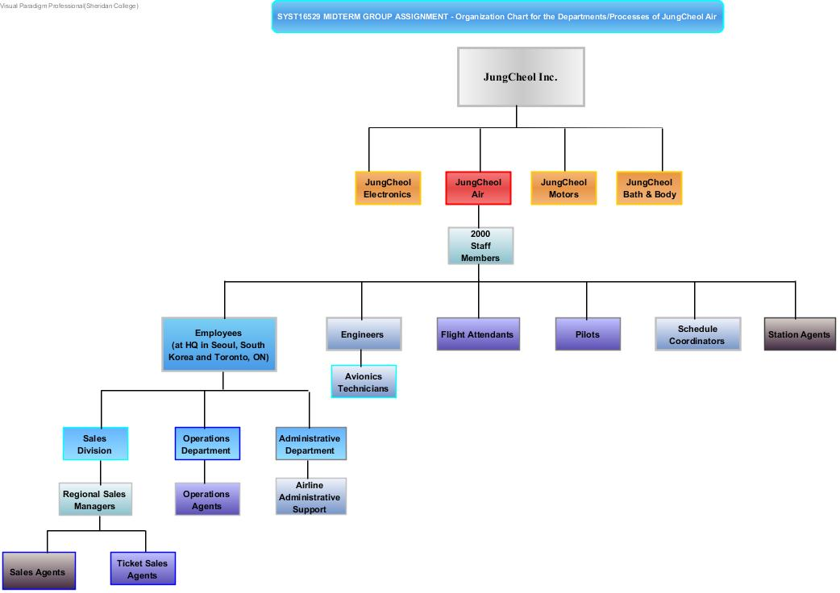

**Marketing: Creating an Advertisement – Use Case Narrative**

Description – This Use Case is concerned with the processes of creating an advertisement of a product and/or a service, in order to increase demand for and sales of that product or service, and thereby boost the overall profits of the company. In this Use Case the main stakeholders are the marketing agents (who act on behalf of the company and represent its advertising interests), and the advertising agency, which is tasked with bringing the company’s advertisements vision to fruition. In such operation structure, the company (represented by the marketing agents) is the customer. That is, it is the party that will be charged for receiving a service (i.e. advertising services provided by the advertising agency). Accordingly, the advertising agency is the party that will be compensated financially -as a result of being the provider of the service (i.e. advertising)-. However, since this process is elaborate and multi-faceted; the company will also play the role of the party that makes financial returns and profits by the time the process concludes. That is, after the advertisement is successfully created and effectively televised, demand for and sales of the product and/or service advertised will increase, which would in turn increase the profits of the company. In order for this Use Case to be successful, the following prerequisites should be met: (i) the marketing agents should have a clear vision of the nature of the advertisement they would like to create; (ii) the company and the advertising agency should reach a well-defined agreement on the criteria for creating the advertisement -including deadline for advertisement submission, and the financial compensation the advertising agency will receive for providing its services-.

|  |  |  |
| --- | --- | --- |
| **Scenario** | Whenever one wishes to sell a product or a service, one first promotes and advertises their service and/or product. In order to accomplish such task one meets with marketing agents and lays out the advertisement content. Thereafter, one enlists the help of advertisement creation professionals (e.g. video editors and screenwriters) in order to bring the project to fruition. Lastly, after the advertisement is fully-prepared and reviewed; it is then released to the public. | |
| **Triggering event** | Desire to promote a certain product or service in order to increase the demand for it or the profit that such product or service generates for the business or company in question. | |
| **Actors** | 1) The marketing agents: these are the individuals tasked with carrying out their company’s plan; which in this case would be to increase profit and demand for certain products by creating effective advertisements. 2) The advertising agency, this party will be in charge of creating an advertisement that accommodates the needs of the hiring company. | |
| **Related use cases** | Selling the advertised product and/or service, financially compensating the advertising agency; which created the advertisement, signing a contract with a broadcast television network to insure that the created advertisement receives sufficient screening and airing time. | |
| **Stakeholders** | 1. The company, which aims to increase the profit generated by a certain product or service through advertising. 2. The marketing agents, who have a vested interest in guarding the company’s advertising goals. That is, if they fail, they might be at risk of losing their job. 3. The advertising agency, which will take full responsibility for manifesting the company’s vision -for the advertisement-. 4. The broadcast television network, which will air and televise the advertisement. 5. The public viewers and audiences, who will either increase the demand for the product (i.e. the advertisement has fulfilled its purpose), or not cause any noticeable increase for the product’s popularity (i.e. in such case the advertisement would not fulfill the purpose for which it has been created. | |
| **Pre-condition** | 1) A clear vision for the advertisement: (i) its content; (ii) the product and/or service it will highlight; (iii) the duration of the advertisement. 2) The marketing agents (i.e. the company representatives) and the advertising should agency agree on of the technicalities of their partnership (e.g. the financial compensation the advertising agency will receive, the deadline for submitting the final version of the advertisement -by the advertising agency-). 3) A contract with the broadcast television network has been signed, and as a result they will provide adequate and sufficient screening for the advertisement, which should provide ample publicity for the company and thereby increase demand for its products. | |
| **Post-condition** | 1) If the objective of the Use Case has been achieved, then the advertisement has been screened (i.e. released to the public), and as a byproduct an increase in demand and sales for the advertised product and/or service will ultimately take place. Furthermore, such state of affairs entails that the advertising agency has been financially compensated for its services, the marketing agents have not lost their job, and the broadcast television network is under contract -with the company- and televising the advertisement sufficiently and in an effective manner. 2) If the objective of the Use Case has not been fulfilled -i.e. the business operation between the company and the advertising agency has not been finalized-; then the advertisement has not come to fruition –i.e. has not been fully created or produced-. As a result, the company’s product or service in question will not experience the desired demand and sales increase, the advertising agency will not be fully compensated for its services, and the marketing agents might lose their job. | |
| **Flow of events** | **Actor** | **System** |
| 1. The company has a desire to promote a certain product or service in order to increase the demand for it or the profit that such product or service generates. 2. Some of the company’s marketing agents are tasked with laying out the advertising content. 3. The marketing agent -on behalf of the company they represent-, meet with an advertising agency and discuss the vision they have for their advertisement. 4. The marketing agents and the advertising company agree on the terms of their partnership (i.e. the compensation the advertising agency will receive and the deadline for submitting the complete and final version of the advertisement). 5. The marketing agents receive the final version of the advertisement. 6. The company reviews the final copy, and decide whether to request any changes to be made (by the advertising agency). 7. The company contacts the broadcasting television network and they both reach an agreement on the approach that should be adopted concerning the airing and screening criteria for the advertisement. 8. The advertisement is screened and televised. 9. Sales and demand for the televised product or service have both increased. | 1. The advertising agency receives the advertisement proposal from the marketing agents. 2. The advertising agency creates the advertisement. 3. The advertising agency provides the marketing agents with a work-in-progress version for the advertisement. 4. Based on the feedback of the marketing agents, the advertising agency modifies the advertisement they have created. 5. The advertising agency provides the company with the final copy of the advertisement. 6. The broadcast television network receive a contract offer from the company. 7. The broadcast television network review the terms of the contract, and thereupon signs it. 8. The advertisement is released to the public. |
| **Exception** | 1. The company does not have sufficient financial capital to cover for its advertising needs. In such case, the company could cut its spending for the following quarter, and only thereafter initiate its new marketing ambitions. 2. An agreement between the company and the advertising agency could not be reached. Alternatively, the company could refer to a different advertising agency. 3. The marketing agents do not guard the company’s interests (i.e. they do not properly depict the advertisement vision -to the advertising company-). In such case, these employees should be fired and replaced with more responsible staff members. | |

**Marketing Diagram**

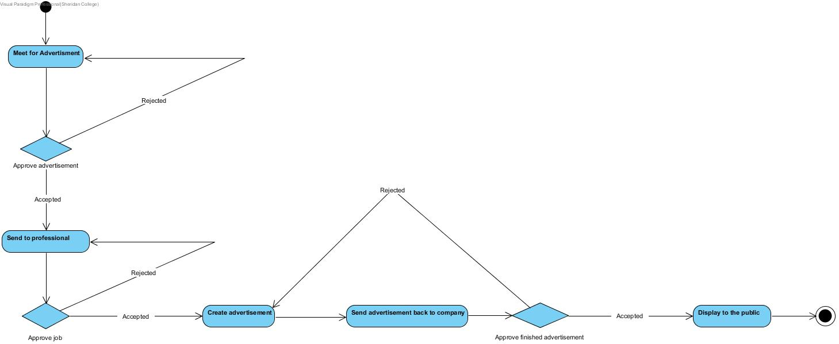

**Purchasing a Plane Ticket Online – Use Case Narrative**

Description – This Use Case is concerned with the process of purchasing a plane ticket online. In this Use Case the main stakeholders are the customer (i.e. the traveler; the ticket purchaser) and the airline company (the plane ticket seller and provider). In such role-hierarchy; the customer will be charged for purchasing the ticket, whereas the seller (i.e. the airline company) will make a profit. In order for this Use Case to be successful, the following prerequisites should be met: (i) the airline company should accommodate the customer’s travel needs (e.g. match the travel date that the customer desires with a convenient flight; (ii) and the customer should have sufficient financial resources to pay for the airline ticket fare, in addition to being equipped with the relevant travel paperwork (e.g. work or tourist or student visa, and a valid passport).

|  |  |  |
| --- | --- | --- |
| **Scenario** | Whenever one desires to travel by air, one has to purchase an online ticket in order to materialize such objective and become eligible for air travel. In order to accomplish this process, one carries out the following steps (in chronological order): (i) access the webpage of the preferred airline; (ii) view available bookings; (iii) shortlist the available bookings in accordance to the desired travel dates; (iv) pick travel dates; (v) insert personal information; (vi) pay for ticket using online payment methods; (vii) save and print a copy of the airline itinerary. | |
| **Triggering event** | The customer has a desire to travel by air, in order to either conclude a business deal, or attend an important conference and/or meeting, or for touristic purposes, and so on. | |
| **Actors** | 1) The customer, the individual who will purchase the ticket. 2) The airline company, i.e. the provider of the airline ticket. | |
| **Related use cases** | Online ticket check-in, changing flight dates, upgrading the airline ticket to business class, redeeming air miles points, selecting passenger seats. | |
| **Stakeholders** | 1. The buyer, i.e. the customer/traveler who will purchase the plane ticket. 2. The seller; the airline company, which will sell the airline ticket. 3. Any individual who is going to use the purchased airline ticket/tickets. | |
| **Pre-condition** | 1) The traveler/customer is well-aware of his/her desired travel date. 2) The airline company is able to provide a travel date that is convenient for the traveler. 3) The traveler/customer possesses sufficient financial resources to pay for the airline ticket. 4) The traveler/customer is able to access the world wide web (i.e. has access to an internet connection). 5) The traveler/customer’s credit card (or any other payment method he/she might choose) is valid. 6) The customer is equipped with the required paperwork for travel -i.e. travel visa and passport-. | |
| **Post-condition** | 1) If the objective of the Use Case has been achieved, then the customer has been able to purchase the desired airline ticket, and the airline company has been compensated financially for providing their services (i.e. providing the customer with an airline ticket, which accommodates his/her needs). 2) If the objective of the Use Case has not been fulfilled -i.e. unsuccessful implementation of the transaction-; then the customer has not been able to purchase an airline ticket, nor has the airline been able to sell one. Thus, the airline has not benefited financially nor has the customer’s travel-oriented desires been met or accommodated. | |
| **Flow of events** | **Actor** | **System** |
| 1. Customer has a desire to travel for business, or educational, or family-related, or touristic purposes. 2. Customer accesses the webpage of his/her preferred airline company. 3. Customer select the flight date and class (economy, business, and so on), which accommodates his/her needs. 4. If a travel itinerary is not available on the desired travel date, then the customer chooses an alternative date, or refers to the webpage of an alternative airline company. 5. Customer provides his personal information (i.e. first/last name, I.D. number and type, and address). 6. Customer pays for the airline ticket fare (if the customer cannot afford the price however, then he/she will refer to an alternative airline company) 7. Customer saves a copy of and prints airline ticket. 8. Customer finalizes ancillary transactions (e.g. choosing aircraft seat, paying for carry-on luggage). | 1. The airline webpage compiles -and then presents- a list of travel options based on the input the customer provides (e.g. preferred travel dates, and travel class).  2. Post-customer’s selection, the airline webpage indicates to the user the amount of money to be charged.  3. The webpage prompts the customer to pay for his/her online itinerary.  4. After the purchasing transaction is compete, the customer is provided with his/her online ticket. |
| **Exception** | 1. The customer erroneously purchases a ticket with a travel date that he/she does not desire nor find convenient, in such case the customer should contact one of the airline’s customer service representatives -by phone or email- and request that the transaction would be voided and terminated.  2. The customer payment method (e.g. credit card, gift card, and so on) is not valid. In such case, the customer should use an alternative method of payment (e.g. alternative credit card, wire transfer) | |

**Plane Booking Activity Diagram**

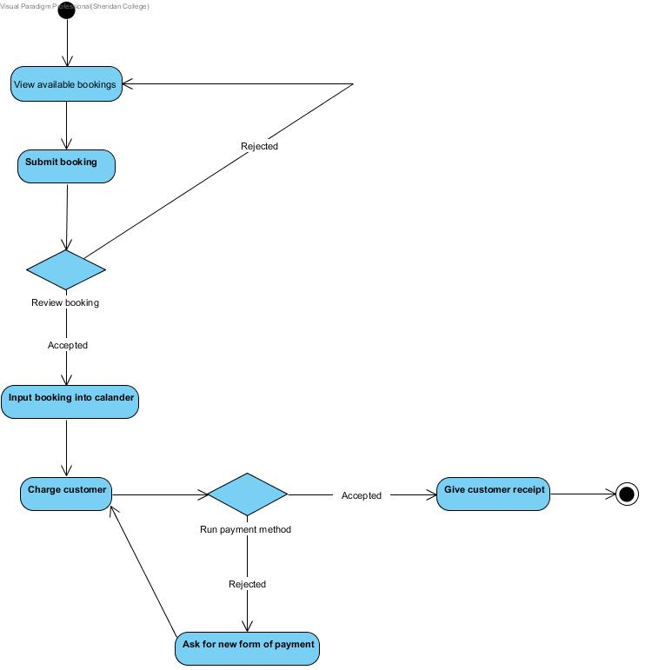

**Works Cited**

* Aeronautical Charges and Fees. (n.d.). Retrieved February 20, 2017, from [https://www.torontopearson.com/en/Airport_Charges_and_Fees/#](https://www.torontopearson.com/en/Airport_Charges_and_Fees/)
* Air Canada Flight Attendant Salaries. (n.d.). Retrieved February 23, 2017, from <https://www.glassdoor.ca/Hourly-Pay/Air-Canada-Flight-Attendant-Hourly-Pay-E42672_D_KO11,27.htm>
* Air Charter Flights & Private Jet Rental. (n.d.). Retrieved February 20, 2017, from<http://www.chartright.com/>
* Air Canada Mechanic Salaries. (n.d.). Retrieved February 23, 2017, from <https://www.glassdoor.ca/Salary/Air-Canada-Mechanic-Salaries-E42672_D_KO11,19.htm>
* Air Canada Regional Sales Manager Salary. (n.d.). Retrieved February 23, 2017, from <https://www.glassdoor.ca/Salary/Air-Canada-Regional-Sales-Manager-Salaries-E42672_D_KO11,33.htm>
* Becoming an Airline Pilot | Latest Pilot Jobs |. (n.d.). Retrieved February 20, 2017, from<http://www.flightdeckfriend.com/how-much-does-jet-fuel-cost>
* Gulfstream Aerospace - Aircraft - G550. (n.d.). Retrieved February 20, 2017, from [http://www.gulfstream.com/aircraft/gulfstream-g5500](http://www.gulfstream.com/aircraft/gulfstream-g550)
* How Much Does a Private Jet Cost to Buy or Hire. (n.d.). Retrieved February 20, 2017, from<http://www.privatejetcosts.net/>